**Department of Electrical Engineering**

**Faculty Member:** Arshad Nazir **Dated:** 17/12/2021

**Semester:** 3rd **Section:** BEE 12C

**Group No.: 7**

**EE-221: Digital Logic Design**

Lab 12: Latches and Flip Flops

|  |  |  |  |  |  |  |  |
| --- | --- | --- | --- | --- | --- | --- | --- |
|  |  | **PLO4/CLO4** | **PLO4/CLO4** | **PLO5/CLO5** | **PLO8/CLO6** | **PLO9/CLO7** |  |
| **Name** | **Reg. No** | **Viva / Lab Performance** | **Analysis of data in Lab Report** | **Modern Tool Usage** | **Ethics and Safety** | **Individual and Teamwork** | **Total marks Obtained** |
|  |  | **5 Marks** | **5 Marks** | **5 Marks** | **5 Marks** | **5 Marks** | **25 Marks** |
| **Muhammad Adil Azeem** | **342459** |  |  |  |  |  |  |
| **Muhammad Umer** | **345834** |  |  |  |  |  |  |
| **Raahim Ahmad Waqar** | **342287** |  |  |  |  |  |  |
| **Saad Bakhtiar** | **341150** |  |  |  |  |  |  |
| **Syed Aun Ali Kazmi** | **342384** |  |  |  |  |  |  |

## Lab 12: Memory Elements

This Lab experiment has been designed to familiarize the students with use of Flip-Flops.

**Objectives:**

* Learn working of SR Latch and the way it can be constructed using NOR and NAND gates
* Modifying the SR Latch circuit to transparent latch (D-Latch)
* Design D type positive edge-triggered Flip-Flop using SR Latched

**Lab Instructions**

* This lab activity comprises three parts, namely Pre-lab, Lab tasks, and Post-Lab Viva session.
* The lab report will be uploaded on LMS three days before scheduled lab date. The students will get hard copy of lab report, complete the Pre-lab task before coming to the lab and deposit it with teacher/lab engineer for necessary evaluation. Alternately each group to upload completed lab report on LMS for grading.
* The students will start lab task and demonstrate design steps separately for stepwise evaluation (course instructor/lab engineer will sign each step after ascertaining functional verification)
* Remember that a neat logic diagram with pins numbered coupled with nicely patched circuit will simplify trouble-shooting process.
* After the lab, students are expected to unwire the circuit and deposit back components before leaving.
* The students will complete lab task and submit complete report to Lab Engineer before leaving lab.
* **The Total duration for the lab is 3 hrs. After lab duration, a deduction of 5 marks per day will be done for late submission.**
* **A lab with in-complete lab tasks will not be accepted.**
* There are related questions at the end of this activity. Give complete answers.

**Pre – Lab Tasks**

**Pre – Lab Task 1**

**Differentiate between the Combinational and Sequential Circuit.**

|  |  |
| --- | --- |
| **Combination Logic** | **Sequential Logic** |
| In this output depends only upon present input. | In this output depends upon present as well as past input. |
| Speed is fast. | Speed is slow. |
| It is designed easy. | It is designed tough as compared to combinational circuits. |
| There is no feedback between input and output. | There exists a feedback path between input and output. |
| This is time independent. | This is time dependent. |
| Elementary building blocks: Logic gates | Elementary building blocks: Flip-flops |
| Used for arithmetic as well as boolean operations. | Mainly used for storing data. |
| Combinational circuits don’t have capability to store any state. | Sequential circuits have capability to store any state or to retain earlier state. |
| As combinational circuits don’t have clock, they don’t require triggering. | As sequential circuits are clock dependent they need triggering. |
| These circuits do not have any memory element. | These circuits have memory element. |
| It is easy to use and handle. | In this output depends upon present as well as past input. |

**Pre – Lab Task 2**

**Differentiate between the Synchronous Sequential logic and Asynchronous Sequential logic.**

|  |  |
| --- | --- |
| **Synchronous Sequential** | **Asynchronous Sequential** |
| Synchronous sequential circuits are digital circuits governed by clock signals. | Asynchronous sequential circuits are digital circuits that are not driven by clock. They can be called as *self-timed circuits.* |
| The transition from one state to another takes place only by the application of specified clock signal*, even if the inputs change. | The transition from one state to another takes place immediately once the inputs change. |
| Clocked flip flops are used as memory elements in synchronous sequential circuits. | Time delayed devices are used as memory elements in asynchronous sequential circuits. |
| The states of synchronous sequential circuits are always predictable and thus reliable. | There are chances for the asynchronous circuits to enter into a wrong state because of the time difference between the arrivals of inputs. |
| Synchronous circuits are used in counters, shift registers, memory unit. | Asynchronous circuits are used in low power and high speed operations. |

**Pre – Lab Task 3**

**Draw the logic diagram of SR Latch using NOR Gates. Also give its function table.**

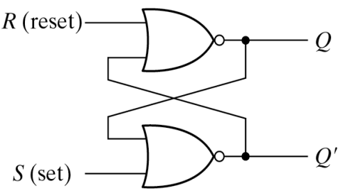

|  |  |  |  |
| --- | --- | --- | --- |
| **S** | **R** | **Q** | **Q’** |
| 1 | 0 | **1** | **0** |
| 0 | 0 | **1** | **0** |
| 0 | 1 | **0** | **1** |
| 0 | 0 | **0** | **1** |
| 1 | 1 | **0** | **0** |

**Pre – Lab Task 4**

**The SR Latch can also be constructed using NAND Gates. Differentiate between the two implementations of SR Latches using Logic Diagram and function table.**

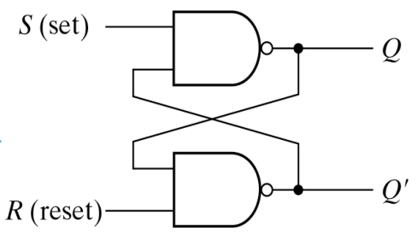

|  |  |  |  |
| --- | --- | --- | --- |
| **S** | **R** | **Q** | **Q’** |
| 1 | 0 | **0** | **1** |
| 1 | 1 | **0** | **1** |
| 0 | 1 | **1** | **0** |
| 1 | 1 | **1** | **0** |
| 0 | 0 | **1** | **1** |

**Common Differences**

* The input signals for the NAND latch requires the complement of those values used for the NOR latch.
* Because the NAND latch requires a 0 signal it is sometimes called a S’R’ latch.

**Pre – Lab Task 5**

**What are the set and reset conditions for SR and S´R´ Latches?**

* For SR Latches, when S = 1 and R = 0, the output Q becomes 1 which is said to be its set – state whereas the inverse, S = 0 and R = 1 makes the output Q = 0, which is the reset – state.
* For S’R’ Latches, the opposite holds true. When S = 0 and R = 1, the output Q becomes 1 which is said to be its set – state whereas the inverse, S = 0 and R = 1 makes the output Q = 0, which is the reset – state.

**Pre – Lab Task 6**

**What is the undefined state for the Latches and how it occurs? How can you evaluate its behavior in this state?**

The undefined state for latches occur when both S & R become 1 for a SR Latch, or both S & R become 0 for S’R’ latch, after which both the outputs become same which is in clear violation as Q and Q’ can never be the same, resulting in unexpected behaviours.

**Pre – Lab Task 7**

**How can we remove the problem of undefined state using D Latch? Give Logic Diagram of D Latch.**

SR Latches with control input can be modelled into a D Latch using a simple condition; that is S and R are complements of each other (R = S’), so that no input can be high at the same time, thereby avoiding the undefined state.

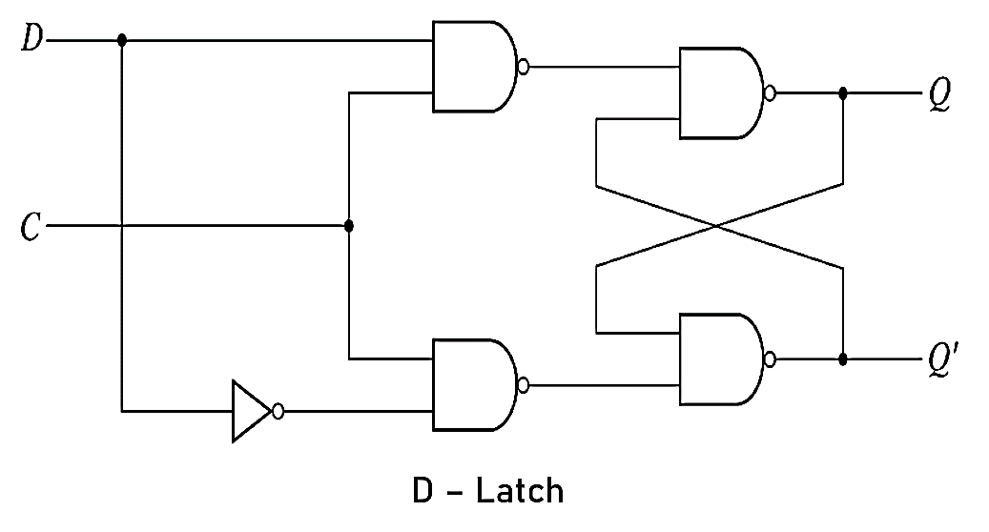

**Pre – Lab Task 8**

**The essential elements of Sequential Circuits are memory elements. The two basic types of memory elements are Latches and Flip-Flops. What is the basic Difference between them?**

|  |  |
| --- | --- |
| **Flip Flops** | **Latches** |
| Flip-flop is a bistable device i.e., it has two states that are represented as 0 and 1. | Latch is also a bistable device whose states are also represented as 0 and 1. |
| It checks the inputs but changes the output only at times defined by the clock signal or any other control signal. | It checks the inputs continuously and responds to the changes in inputs immediately. |
| It is a edge triggered device. | It is a level triggered device. |
| It forms the building blocks of many sequential circuits like counters. | These can be used for the designing of sequential circuits but are not generally preferred. |
| Flip-flop can be build from Latches | Latches can be build from gates |

**Pre – Lab Task 9**

**Give the graphic symbols for SR, S’R’ and D Latch.**

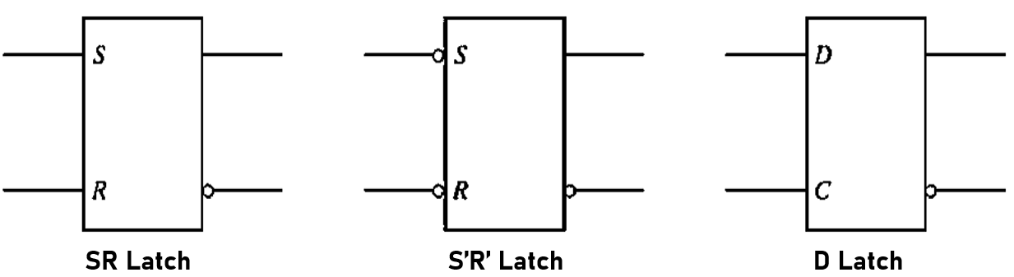

**Lab Tasks**

**Lab Task 1**

**Implement the SR Latch using a) NOR and b) NAND gates and show it to Lab Instructor. Give Logic Diagram, Function Table, and State Table for both designs. What is the difference between the two implementations?**

**Hardware Implementation**

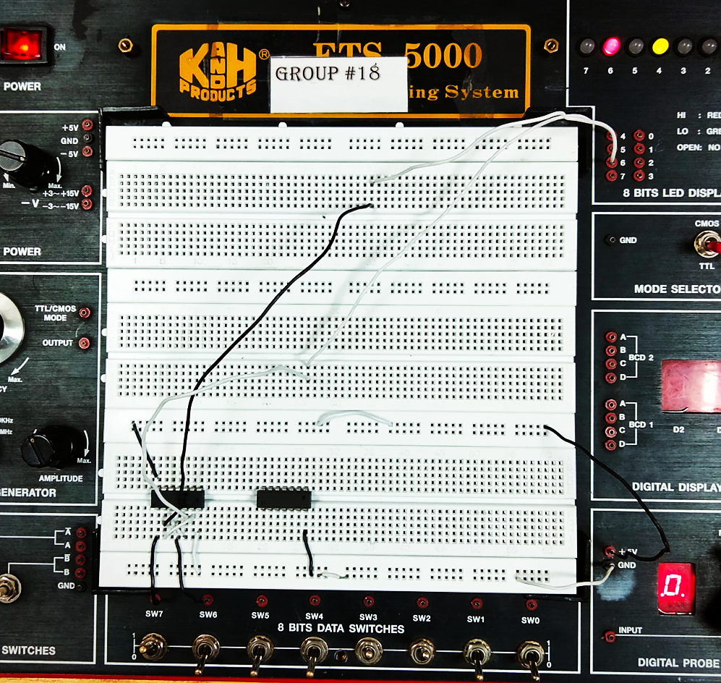

**Proteus Simulation**

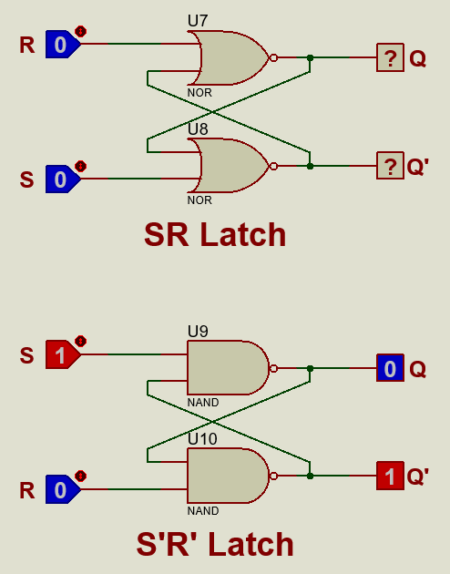

**Lab Task 2**

**Implement the D-Latch and show it to your Lab Instructor. Give Logic Diagram and Function Table. What advantage does it have over SR Latch?**

**Hardware Implementation**

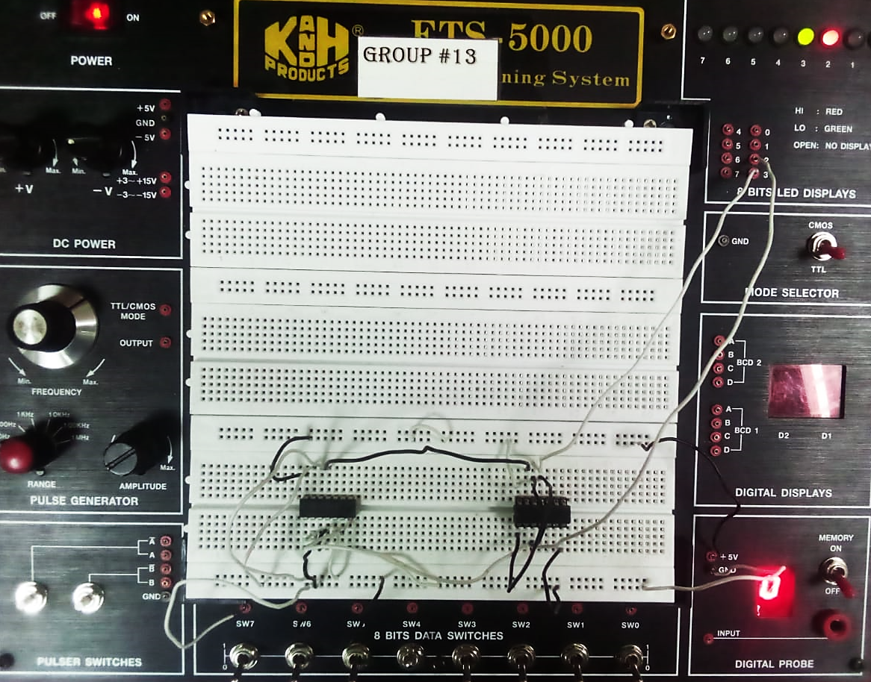

**Proteus Simulation**

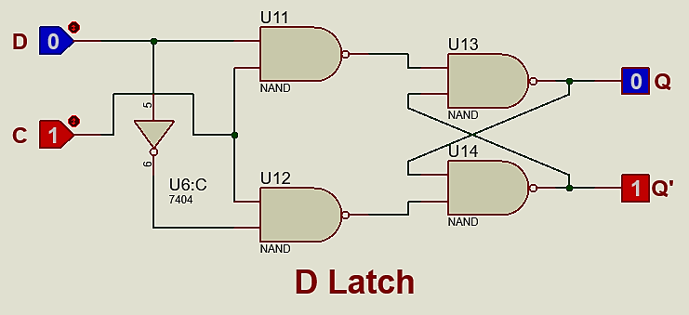

**Lab Task 3**

**Implement a D-type positive edge-triggered Flip-Flop using S.R. latches. What gates would you need for the implementation? Give Logic Diagram, Graphic Symbols and Characteristic Table. What change would be needed to design a negative edge triggered Flip-Flop?**

**Hardware Implementation**

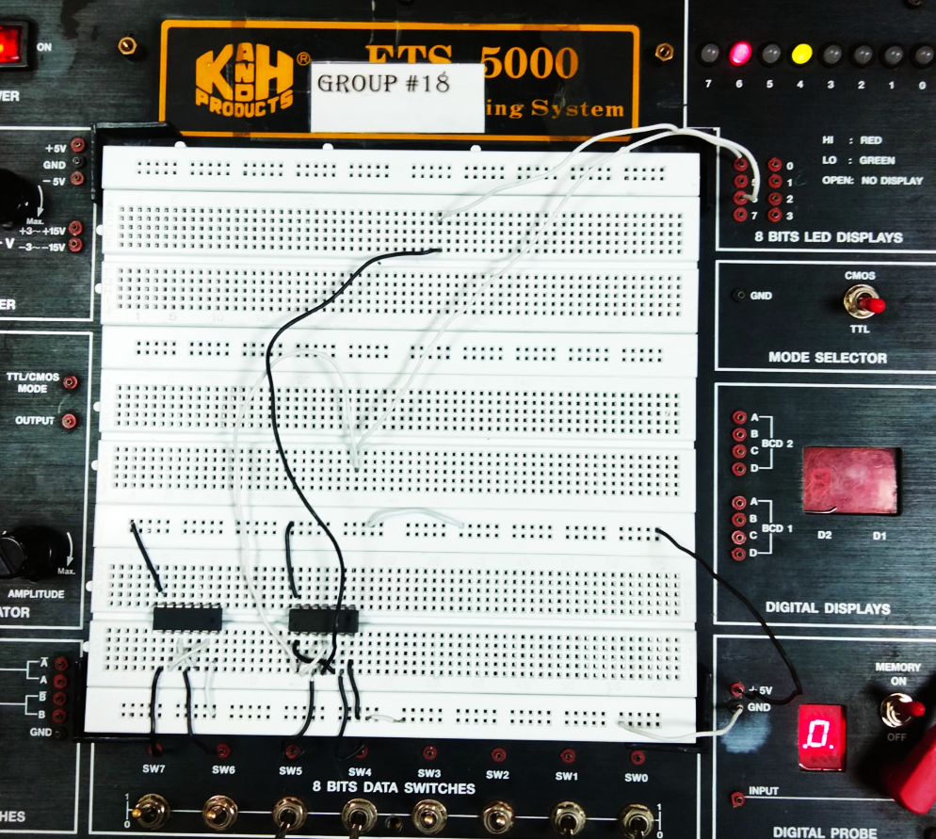

**Proteus Simulation**

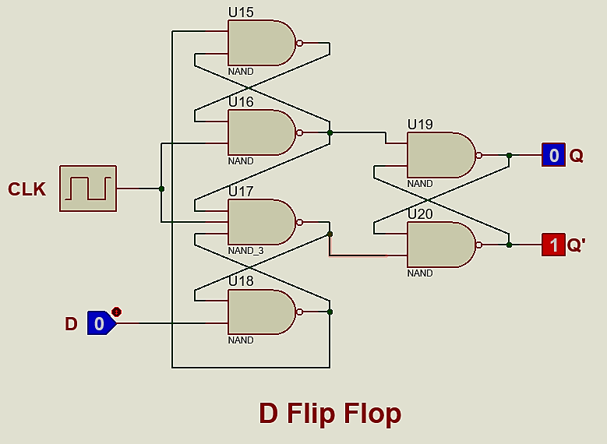

**Lab Task 4**

**Add CLEAR (Direct-reset) and PRESET (Direct-set) to the Flip-Flop. What are the function of these inputs?**

**Hardware Implementation**

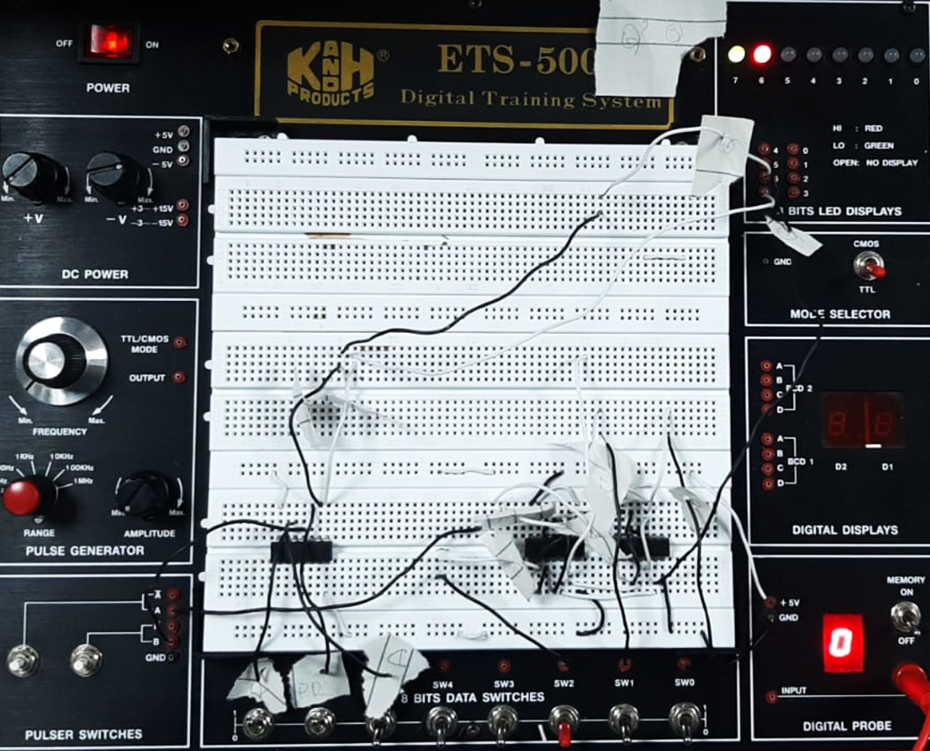

**Proteus Simulation**

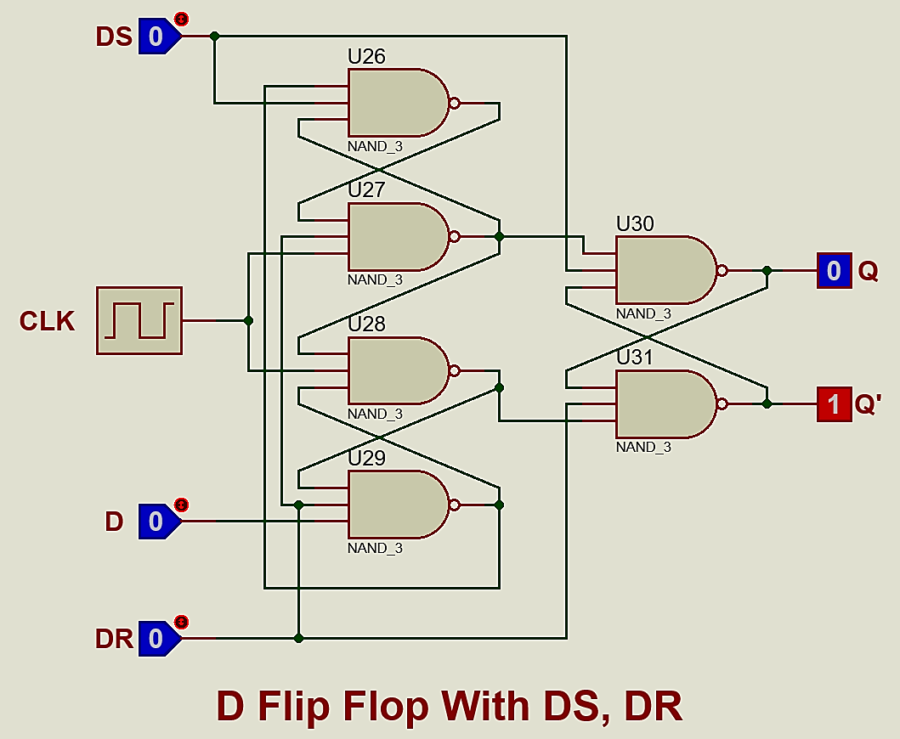

**Lab Task 5**

**D Flip-Flop IC is 7474. Give its PIN Configuration, Function table and internal IC circuit. Draw its state diagram and compare working of IC your design.**

**Hardware Implementation**

